999 VisualStudio - updating packages

TypeScript Kata List – Blog Page

[TypeScript Kata List on GitHub](https://github.com/robertdunaway/katas-typescript)

# Duration

[minutes]

# Brief

Updating the development packages we depend on.

### For More Information

BING/GOOGLE: “Visual Studio ”

# Instructions

Get tutorial folder or the entire katas-typescript repo.

Open the [before/*.sln] file and execute the kata.

Feel free to execute this kata multiple times because repetition creates motor memory.

# Github

* Before (start kata with this)
  + [https://github.com/](https://github.com/robertdunaway/katas-typescript/tree/master/001%20TypeScript%20-%20declare%20variables)
* After
  + [https://github.com/](https://github.com/robertdunaway/katas-typescript/tree/master/001%20TypeScript%20-%20declare%20variables/after)

# Kata

# Updating NPM packages

References

* <http://davidwalsh.name/upgrade-nodejs>
* <http://theholmesoffice.com/node-js-fundamentals-how-to-upgrade-the-node-js-version/>

Initially, after pulling down a project, the NPM packages will not have been installed. If you are using Visual Studio then your packages will be automatically downloaded.

Otherwise run the NPM install command.

npm install

You’ll get some strange looking screen that looks like this. No, I don’t know what all that is.

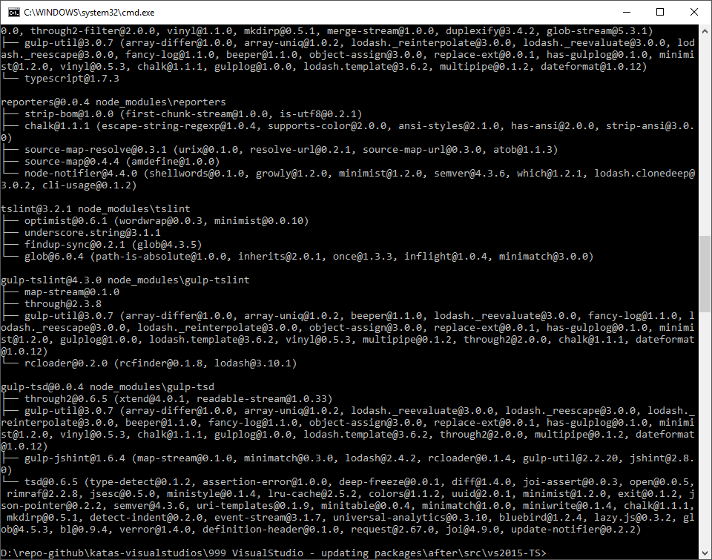

Identify which NPM packages are out of date

Display colored rows

npm outdated -–depth=0

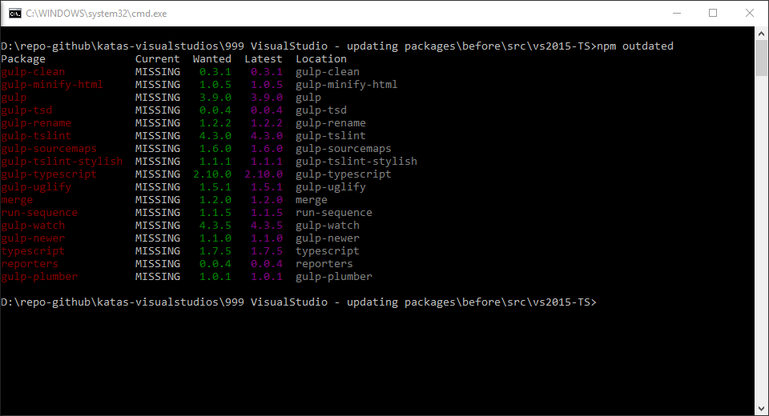

Display in json which includes current, wanted, latest version numbers.

npm outdated --json --depth=0

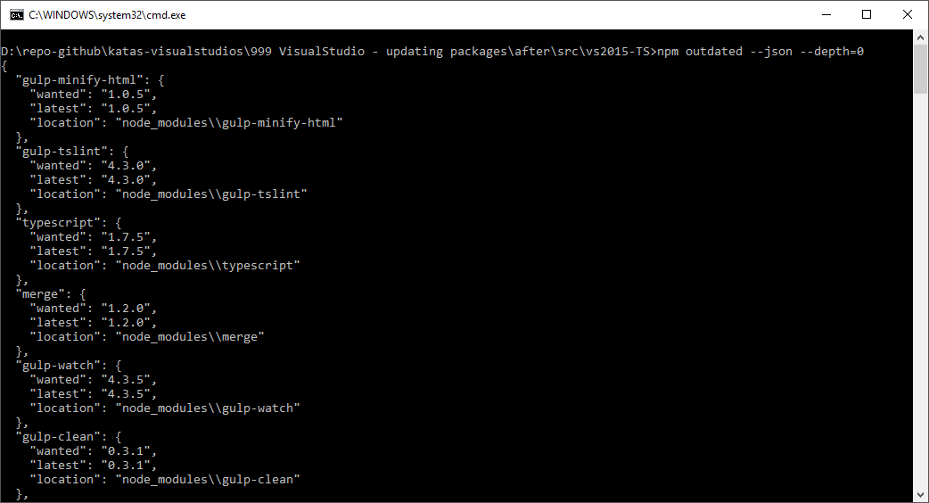

To update packages one at a time. This command not only installed the latest stable release of the plugin but updates your package.json as well.

npm install [package-name]@* --save-dev

Example:

npm install gulp-clean@* --save-dev

The end result after executing this command against all npm packages.

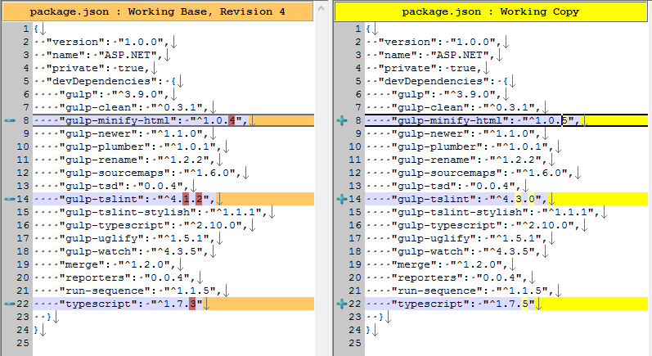

Global NPM packages are updated in the same way.

npm outdated -g

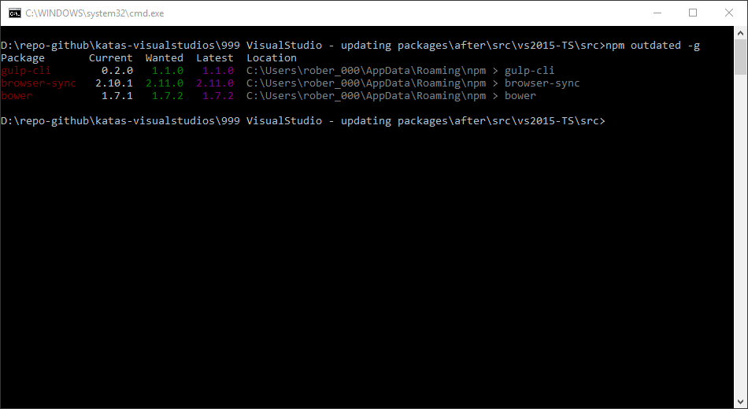

Update global packages

npm install gulp-cli@* -g

# Updating Bower packages

Get a list of Bower packages that have updates available

bower list

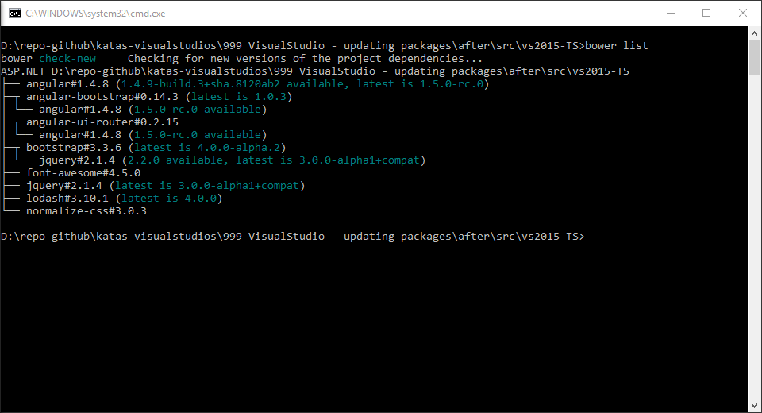

Updating individual Bower packages to the latest available package.

Syntax: bower install --save [package_name]#latest

bower install --save angular#latest

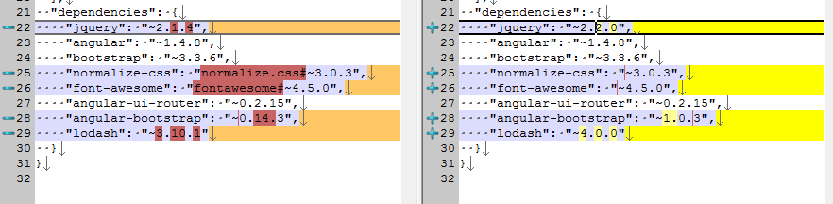

# Next

Take a few minutes and imagine more examples.